1. codes

I-App.c

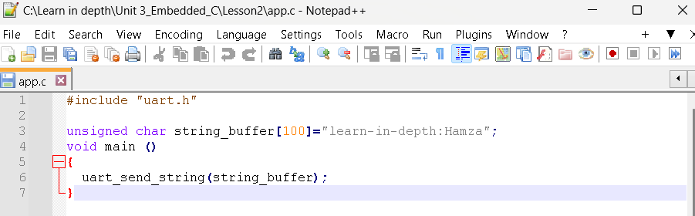

II-uart.c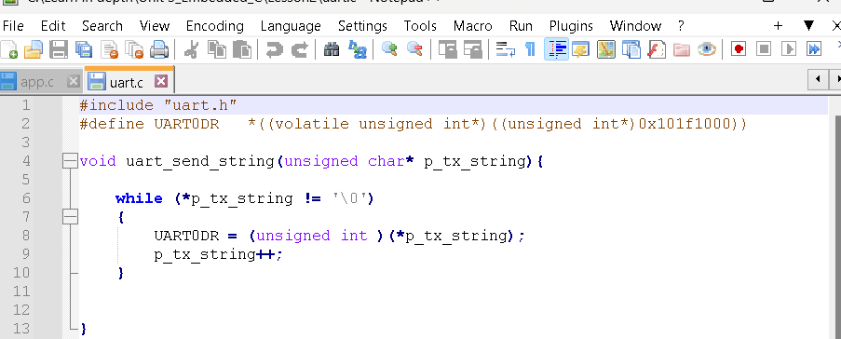

III-uart.h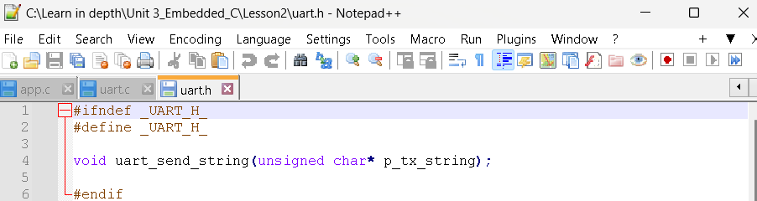

IIII-Startup.s

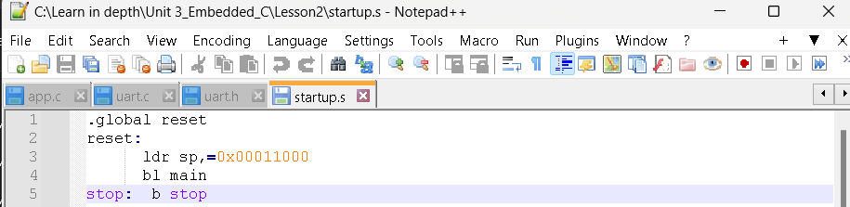

To show sections for object_file

-App.o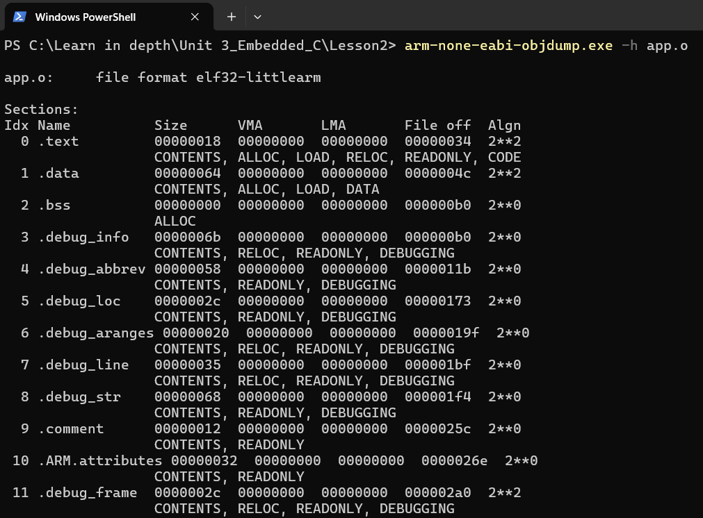

-Uart.o

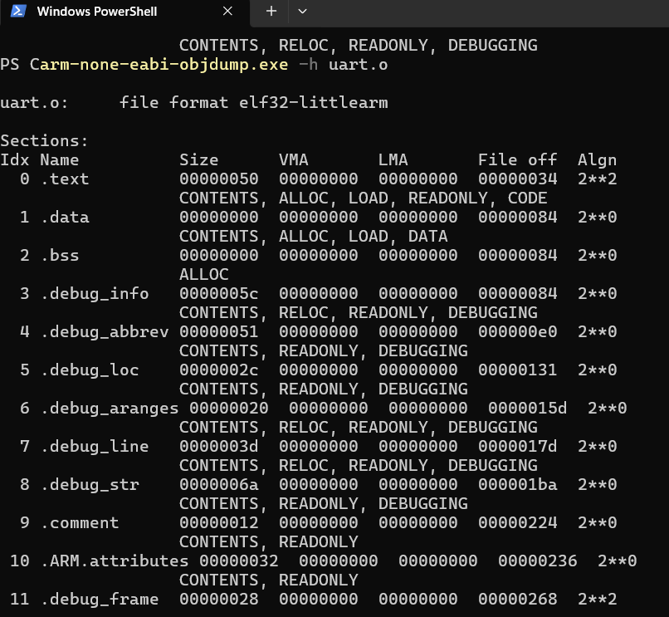

-Startup.o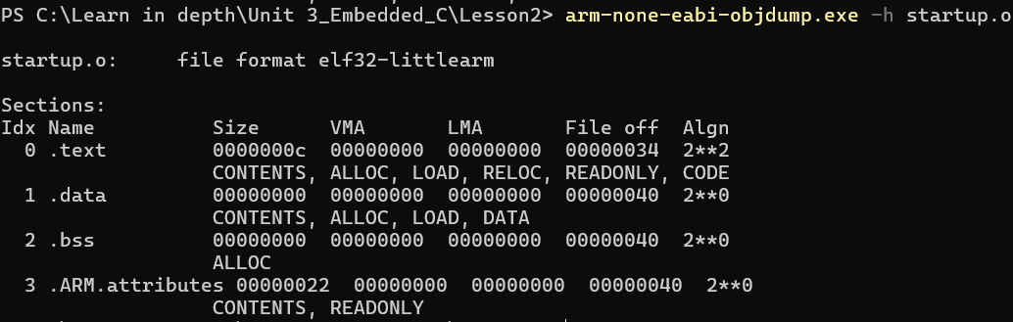

- To show symbol table for App.o Uart.o and startup.o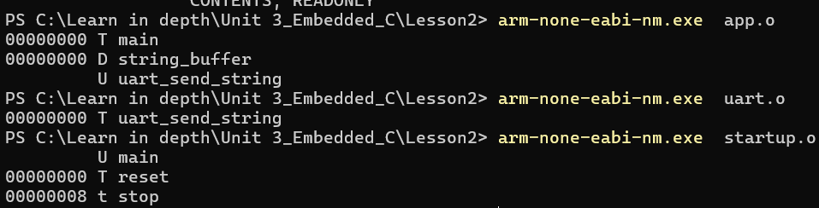

2-use linker_script to get executable_file (App.elf) and map_file



To show sections for learn in depth.elf

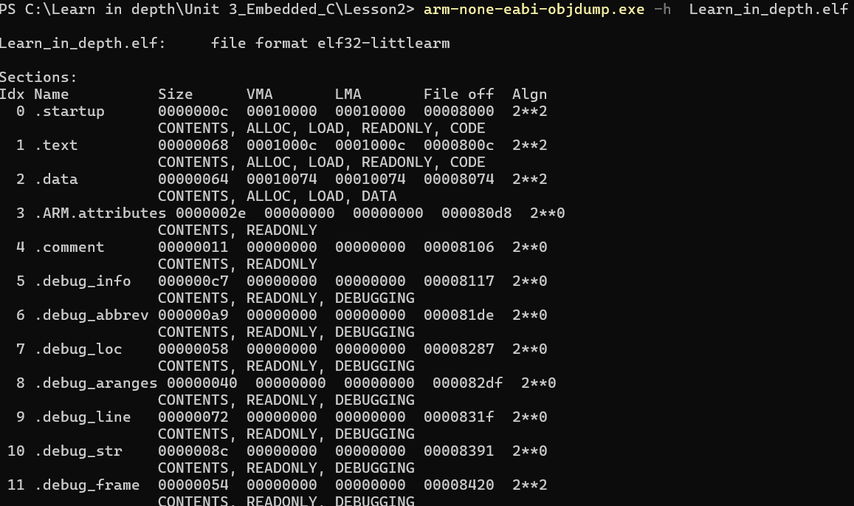

3-get binary file to use in burn

$ arm-none-eabi-objcopy.exe -O binary Learn_in_depth.elf Learn_in_depth.bin

4- burn binary file on board using qemu